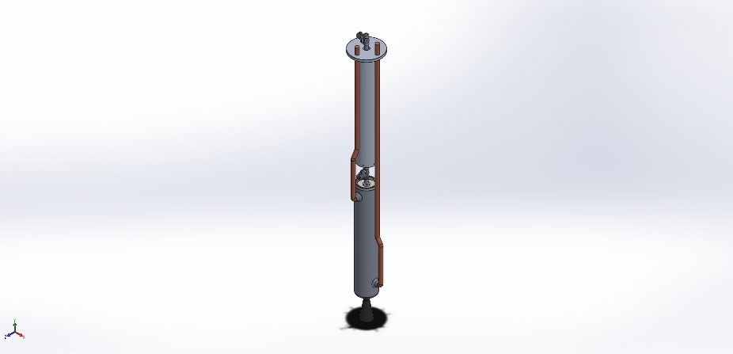
  Simulation of Assem1
  Date: September 2, 2020
  Designer: Solidworks
  Study name: Static 2
  Analysis type: Static
  Table of Contents
  Description 1
  Assumptions 2
  Model Information 2
  Study Properties 5
  Units 5
  Material Properties 6
  Loads and Fixtures 8
  Connector Definitions 8
  Contact Information 8
  Mesh information 9
  Sensor Details 9
  Resultant Forces 9
  Beams 9
  Study Results 9
  Conclusion 9

Description
No Data

Assumptions

Model Information

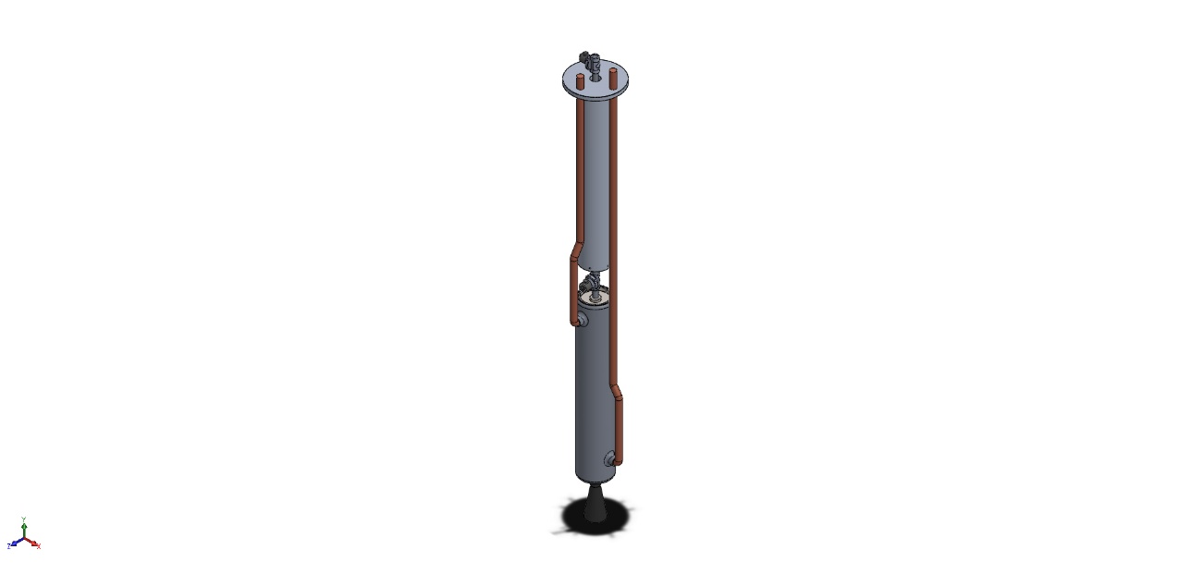
Model name: Assem1
Current Configuration: Default
Solid Bodies
Document Name and Reference | Treated As | Volumetric Properties | Document Path/Date Modified
Cut-Extrude3  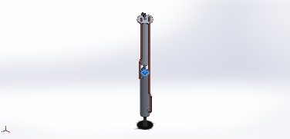 | Solid Body | Mass:0.012469 kg  Volume:2.76473e-06 m^3  Density:4,510 kg/m^3  Weight:0.122196 N | C:\Users\jonas\Desktop\UVic ROcket\Model rocket pocket files\bulkhead 1.SLDPRT  Aug 31 21:18:27 2020
Cut-Extrude3  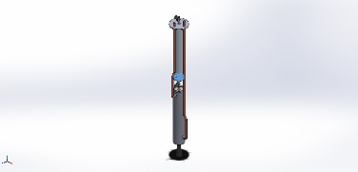 | Solid Body | Mass:0.012469 kg  Volume:2.76473e-06 m^3  Density:4,510 kg/m^3  Weight:0.122196 N | C:\Users\jonas\Desktop\UVic ROcket\Model rocket pocket files\bulkhead 1.SLDPRT  Aug 31 21:18:27 2020
Cut-Extrude2  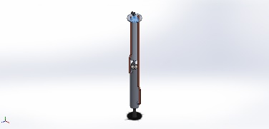 | Solid Body | Mass:0.0289444 kg  Volume:6.41784e-06 m^3  Density:4,510 kg/m^3  Weight:0.283656 N | C:\Users\jonas\Desktop\UVic ROcket\Model rocket pocket files\bulkhead 2.SLDPRT  Sep 1 12:28:14 2020
CirPattern4  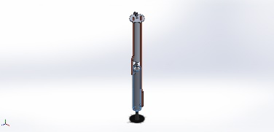 | Solid Body | Mass:0.0913731 kg  Volume:3.38419e-05 m^3  Density:2,700 kg/m^3  Weight:0.895457 N | C:\Users\jonas\Desktop\UVic ROcket\Model rocket pocket files\casing for fuel rod.SLDPRT  Aug 30 16:11:15 2020
CirPattern4  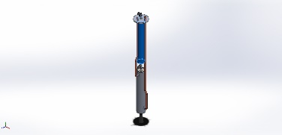 | Solid Body | Mass:0.0914744 kg  Volume:3.38794e-05 m^3  Density:2,700 kg/m^3  Weight:0.896449 N | C:\Users\jonas\Desktop\UVic ROcket\Model rocket pocket files\casing for oxydizer.SLDPRT  Sep 1 13:15:51 2020
Fillet3  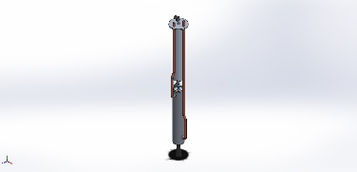 | Solid Body | Mass:0.000827621 kg  Volume:2.95579e-07 m^3  Density:2,800 kg/m^3  Weight:0.00811069 N | C:\Users\jonas\Desktop\UVic ROcket\Model rocket pocket files\connector to valve and casing.SLDPRT  Aug 31 19:36:32 2020
Fillet3  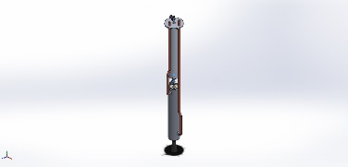 | Solid Body | Mass:0.000827621 kg  Volume:2.95579e-07 m^3  Density:2,800 kg/m^3  Weight:0.00811069 N | C:\Users\jonas\Desktop\UVic ROcket\Model rocket pocket files\connector to valve and casing.SLDPRT  Aug 31 19:36:32 2020
Fillet3  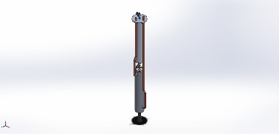 | Solid Body | Mass:0.000827621 kg  Volume:2.95579e-07 m^3  Density:2,800 kg/m^3  Weight:0.00811069 N | C:\Users\jonas\Desktop\UVic ROcket\Model rocket pocket files\connector to valve and casing.SLDPRT  Aug 31 19:36:32 2020
Fillet4  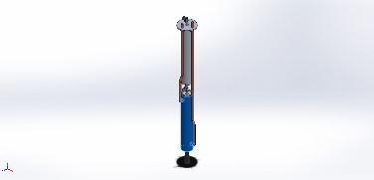 | Solid Body | Mass:0.167752 kg  Volume:5.99113e-05 m^3  Density:2,800 kg/m^3  Weight:1.64397 N | C:\Users\jonas\Desktop\UVic ROcket\Model rocket pocket files\coolant casing.SLDPRT  Sep 2 12:15:52 2020
Sweep22  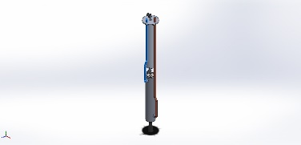 | Solid Body | Mass:0.148097 kg  Volume:1.66401e-05 m^3  Density:8,900 kg/m^3  Weight:1.45135 N | C:\Users\jonas\Desktop\UVic ROcket\Model rocket pocket files\coolant pipe hybrid.SLDPRT  Sep 2 15:02:34 2020
Sweep22  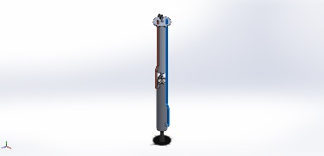 | Solid Body | Mass:0.233031 kg  Volume:2.61832e-05 m^3  Density:8,900 kg/m^3  Weight:2.2837 N | C:\Users\jonas\Desktop\UVic ROcket\Model rocket pocket files\coolant pipe.SLDPRT  Sep 2 14:46:51 2020
Boss-Extrude1  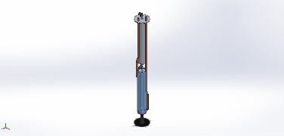 | Solid Body | Mass:0.15771 kg  Volume:0.000164282 m^3  Density:960 kg/m^3  Weight:1.54556 N | C:\Users\jonas\Desktop\UVic ROcket\Model rocket pocket files\feul rod rubber.SLDPRT  Aug 30 16:34:39 2020
CirPattern1  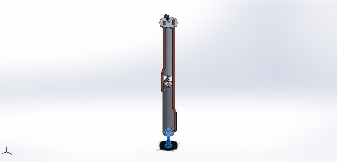 | Solid Body | Mass:0.0304259 kg  Volume:1.3583e-05 m^3  Density:2,240 kg/m^3  Weight:0.298174 N | C:\Users\jonas\Desktop\UVic ROcket\Model rocket pocket files\nozzle.SLDPRT  Aug 25 18:34:32 2020
Scale1  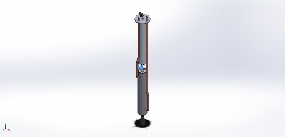 | Solid Body | Mass:2.37044e-06 kg  Volume:2.37044e-06 m^3  Density:1 kg/m^3  Weight:2.32303e-05 N | C:\Users\jonas\Desktop\UVic ROcket\Model rocket pocket files\solenoid valve.SLDPRT  Sep 1 12:43:02 2020
Scale1  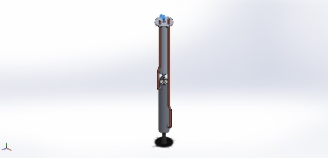 | Solid Body | Mass:2.37044e-06 kg  Volume:2.37044e-06 m^3  Density:1 kg/m^3  Weight:2.32303e-05 N | C:\Users\jonas\Desktop\UVic ROcket\Model rocket pocket files\solenoid valve.SLDPRT  Sep 1 12:43:02 2020
Fillet1  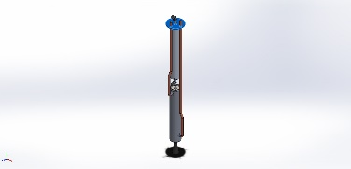 | Solid Body | Mass:0.0490108 kg  Volume:1.81522e-05 m^3  Density:2,700 kg/m^3  Weight:0.480306 N | C:\Users\jonas\Desktop\UVic ROcket\Model rocket pocket files\top part above the oxygen chamber.SLDPRT  Sep 2 15:52:11 2020

Study Properties
Study name | Static 2
Analysis type | Static
Mesh type | Solid Mesh
Thermal Effect: | On
Thermal option | Include temperature loads
Zero strain temperature | 298 Kelvin
Include fluid pressure effects from SOLIDWORKS Flow Simulation | Off
Solver type | FFEPlus
Inplane Effect: | Off
Soft Spring: | Off
Inertial Relief: | Off
Incompatible bonding options | Automatic
Large displacement | Off
Compute free body forces | On
Friction | Off
Use Adaptive Method: | Off
Result folder | SOLIDWORKS document (c:\users\jonas\appdata\local\temp)

Units
Unit system: | SI (MKS)
Length/Displacement | mm
Temperature | Kelvin
Angular velocity | Rad/sec
Pressure/Stress | N/m^2

Material Properties
Model Reference | Properties | Components
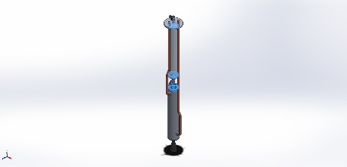 |  | SolidBody 1(Cut-Extrude3)(bulkhead 1-1),  SolidBody 1(Cut-Extrude3)(bulkhead 1-2),  SolidBody 1(Cut-Extrude2)(bulkhead 2-1)
  Name: | Commercially Pure CP-Ti UNS R50400 (SS)
  Model type: | Linear Elastic Isotropic
  Default failure criterion: | Unknown
  Yield strength: | 3.7e+08 N/m^2
  Tensile strength: | 3.44e+08 N/m^2
  Elastic modulus: | 1.05e+11 N/m^2
  Poisson's ratio: | 0.37
  Mass density: | 4,510 kg/m^3
  Shear modulus: | 4.5e+10 N/m^2
  Thermal expansion coefficient: | 9e-06 /Kelvin
Curve Data:N/A
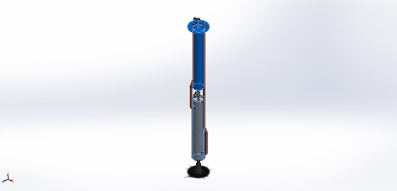 |  | SolidBody 1(CirPattern4)(casing for fuel rod-1),  SolidBody 1(CirPattern4)(casing for oxydizer-1),  SolidBody 1(Fillet1)(top part above the oxygen chamber-1)
  Name: | 1060 Alloy
  Model type: | Linear Elastic Isotropic
  Default failure criterion: | Unknown
  Yield strength: | 2.75742e+07 N/m^2
  Tensile strength: | 6.89356e+07 N/m^2
  Elastic modulus: | 6.9e+10 N/m^2
  Poisson's ratio: | 0.33
  Mass density: | 2,700 kg/m^3
  Shear modulus: | 2.7e+10 N/m^2
  Thermal expansion coefficient: | 2.4e-05 /Kelvin
Curve Data:N/A
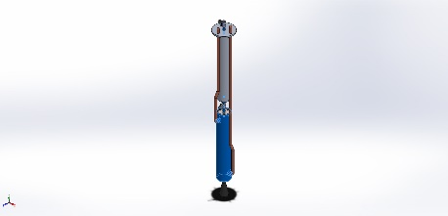 |  | SolidBody 1(Fillet3)(connector to valve and casing-1),  SolidBody 1(Fillet3)(connector to valve and casing-2),  SolidBody 1(Fillet3)(connector to valve and casing-3),  SolidBody 1(Fillet4)(coolant casing-1)
  Name: | 201.0-T6 Insulated Mold Casting (SS)
  Model type: | Linear Elastic Isotropic
  Default failure criterion: | Unknown
  Yield strength: | 3.49e+08 N/m^2
  Tensile strength: | 3.59e+08 N/m^2
  Elastic modulus: | 7.1e+10 N/m^2
  Poisson's ratio: | 0.33
  Mass density: | 2,800 kg/m^3
  Shear modulus: | 2.3e+10 N/m^2
  Thermal expansion coefficient: | 3.5e-05 /Kelvin
Curve Data:N/A
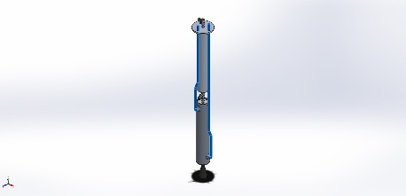 |  | SolidBody 1(Sweep22)(coolant pipe hybrid-1),  SolidBody 1(Sweep22)(coolant pipe-1)
  Name: | Copper
  Model type: | Linear Elastic Isotropic
  Default failure criterion: | Unknown
  Yield strength: | 2.58646e+08 N/m^2
  Tensile strength: | 3.9438e+08 N/m^2
  Elastic modulus: | 1.1e+11 N/m^2
  Poisson's ratio: | 0.37
  Mass density: | 8,900 kg/m^3
  Shear modulus: | 4e+10 N/m^2
  Thermal expansion coefficient: | 2.4e-05 /Kelvin
Curve Data:N/A
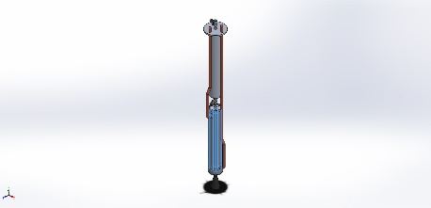 |  | SolidBody 1(Boss-Extrude1)(feul rod rubber-1)
  Name: | Natural Rubber
  Model type: | Linear Elastic Isotropic
  Default failure criterion: | Unknown
  Tensile strength: | 2e+07 N/m^2
  Elastic modulus: | 10,000 N/m^2
  Poisson's ratio: | 0.45
  Mass density: | 960 kg/m^3
Curve Data:N/A
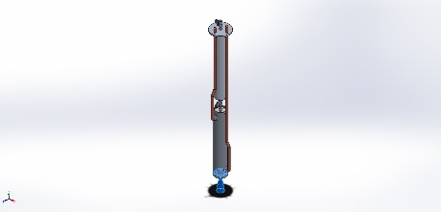 |  | SolidBody 1(CirPattern1)(nozzle-1)
  Name: | C (Graphite)
  Model type: | Linear Elastic Isotropic
  Default failure criterion: | Unknown
  Yield strength: | 1.20594e+08 N/m^2
  Tensile strength: | 1.00826e+08 N/m^2
  Elastic modulus: | 4.8e+09 N/m^2
  Poisson's ratio: | 0.28
  Mass density: | 2,240 kg/m^3
  Thermal expansion coefficient: | 1.3e-05 /Kelvin
Curve Data:N/A

Loads and Fixtures

Load name | Load Image | Load Details
Pressure-1 | 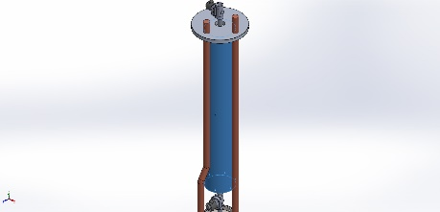
  Entities: | 1 face(s)
  Type: | Normal to selected face
  Value: | 3,000
  Units: | N/m^2
  Phase Angle: | 0
  Units: | deg
Temperature-1 | 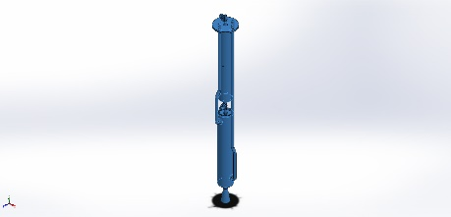
  Entities: | 3 face(s), 16 component(s)
  Temperature: | 1,400 Kelvin

Connector Definitions
No Data

Contact Information

Contact | Contact Image | Contact Properties
Global Contact | 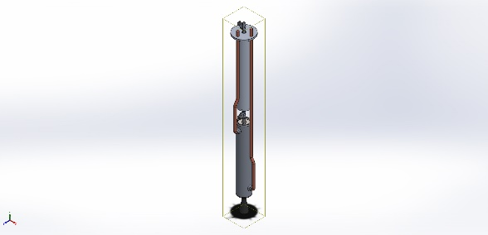
  Type: | Bonded
  Components: | 1 component(s)
  Options: | Compatible mesh

Mesh information
No Data

Sensor Details
No Data

Resultant Forces
No Data

Beams
No Data

Study Results
No Data

Conclusion

